Nurture approach

Purpose of a nurture group
To help schools improve behaviour, attendance and attainment.

How
It helps children develop their emotional and social skills, confidence and self-esteem. Following the 6 principles of nurture.

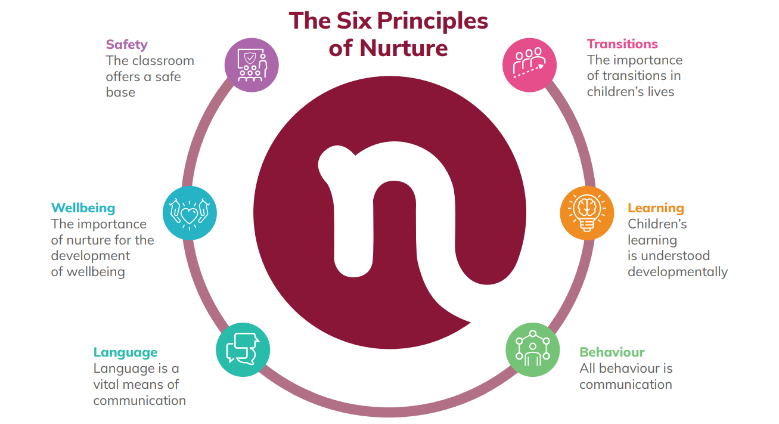

Useful info
- Dave Whitaker: The kindness principle (unconditional positive regard) https://www.youtube.com/watch?v=Utjs2UuCxGc
- Genuine love gives us an ability to deal with life and a sense of being understood and safe. Andrew Curran.
- Window of tolerance can be widened with regulating strategies – creativity, nature, mindfulness, relationships, exercise, music, laughter, positive touch, stress and trauma reduces it.
- Babies are born with 100 billion neurons! It’s the connections that help to develop and grow them.
- ACES and trauma cause toxic stress, Toxic stress can be reduced when relationships are nurturing, engaging and stable.
- Attachment theory: Bowlby worked with a group of young offenders and discovered clear links to anti-social behaviour and children that had been separated from their family.
- Safety, security and stability is needed in a relationship for: self-esteem, to be able to ask for help, development of the stress regulatory systems, fulfilling relationships, have the capacity for empathy and for exploring and learning about the world around us. This then helps to regulate your emotions, view yourself and others positively and to form and maintain relationships.
- Need to teach co-regulation before expecting self regulation.
- Attachment is a hidden regulator, a child will look for someone to solve their distress (their limbic system is telling them there is a problem) if no-one is there then they will look for pathological regulation (alcohol, drugs, risky sex etc).
- Key is building relationships that reduce stress and help them feel safe, understood and supported.
- Children with insecure attachments feel shame more easily.
- Adults need to be modelling the desired behaviour and teaching it!
- Behaviour contains a message that needs to be interpreted.
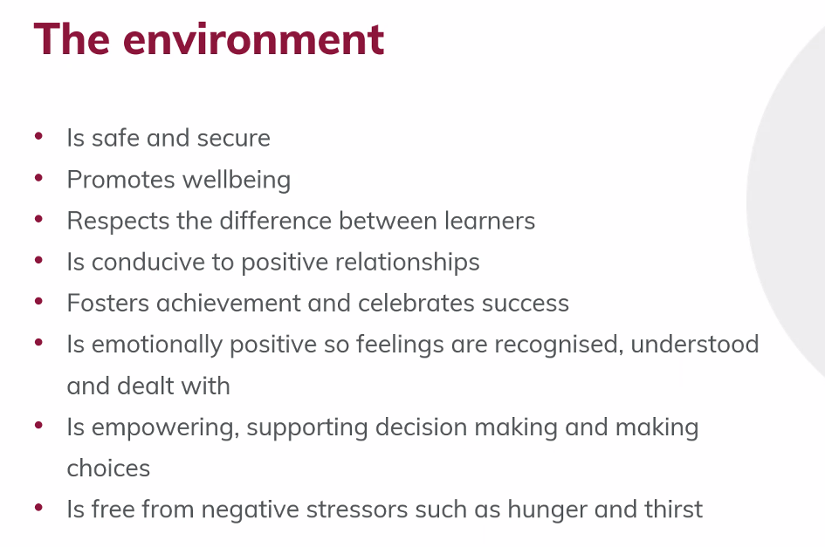
Useful links

brain function neurons and synapsis

unlocking adolescent mind

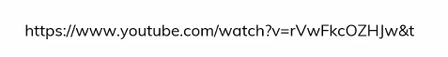 toxic stress
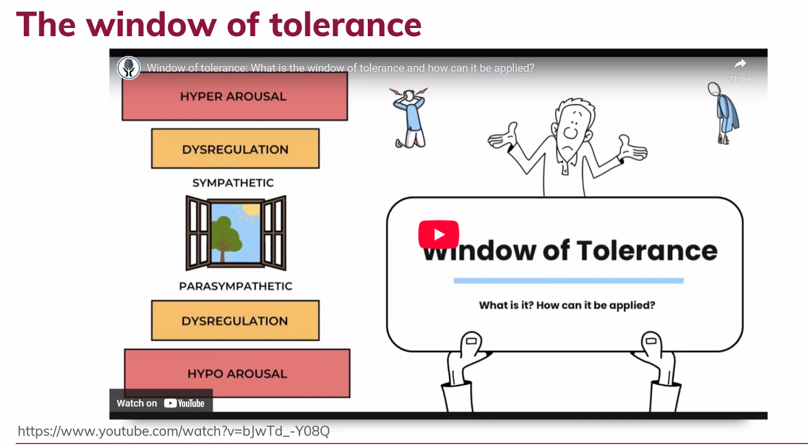

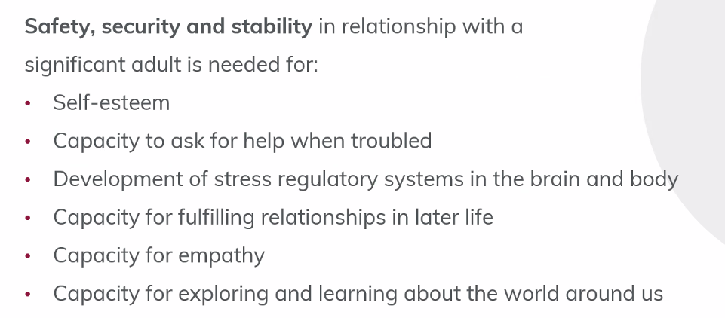

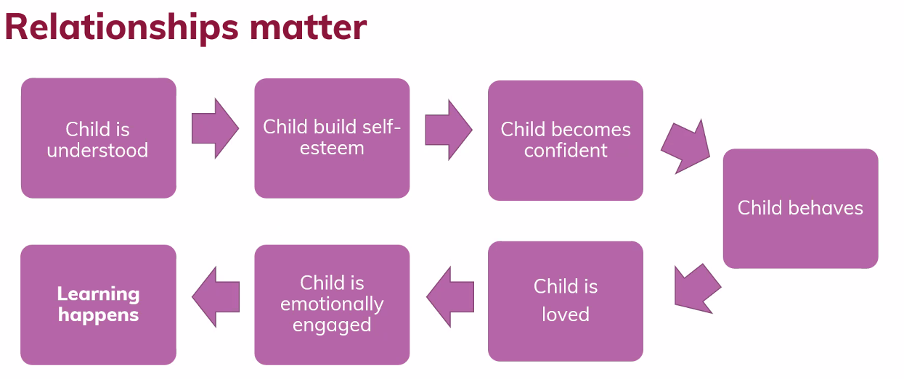
Dave Whitaker
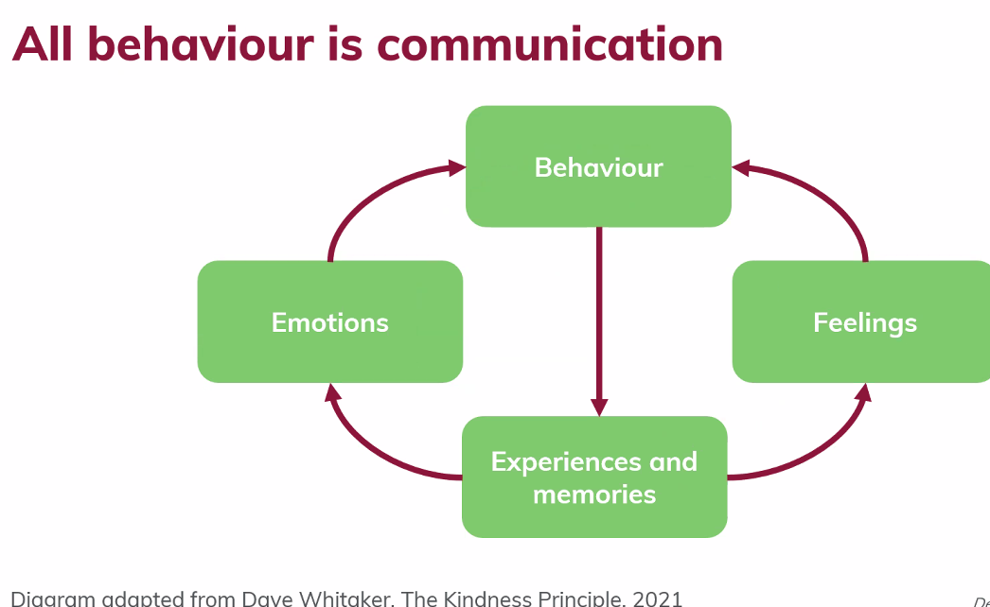
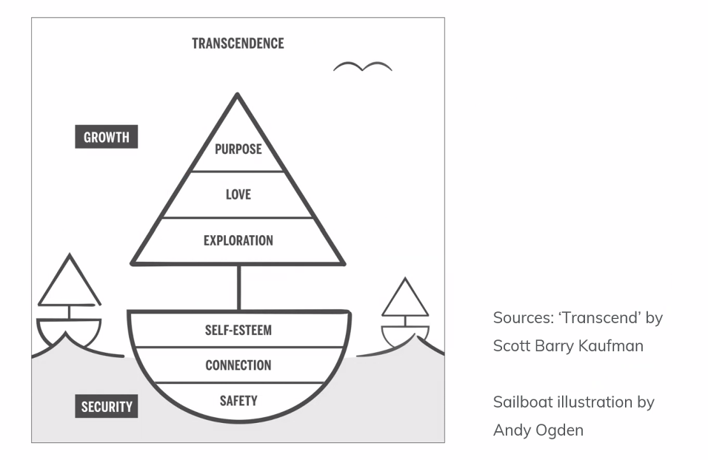original Maslow idea (split)

